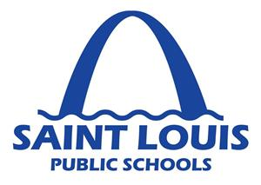

**Dr. Amy Phillips**

Principal

**Mr. Perry Anselman**

Assistant Principal